Software Requirements Specification
for
< SMART SEARCH for EDUCATION >
Version 1.0 approved
Prepared by <author>
<organization>
<date created>
Table of Contents
Table of Contents ii
Revision History ii
1. Introduction 1
1.1 Purpose 1
1.2 Document Conventions 1
1.3 Intended Audience and Reading Suggestions 1
1.4 Product Scope 1
1.5 References 1
2. Overall Description 2
2.1 Product Perspective 2
2.2 Product Functions 2
2.3 User Classes and Characteristics 2
2.4 Operating Environment 2
2.5 Design and Implementation Constraints 2
2.6 User Documentation 2
2.7 Assumptions and Dependencies 3
3. External Interface Requirements 3
3.1 User Interfaces 3
3.2 Hardware Interfaces 3
3.3 Software Interfaces 3
3.4 Communications Interfaces 3
4. System Features 4
4.1 System Feature 1 4
4.2 System Feature 2 (and so on) 4
5. Other Nonfunctional Requirements 4
5.1 Performance Requirements 4
5.2 Safety Requirements 5
5.3 Security Requirements 5
5.4 Software Quality Attributes 5
5.5 Business Rules 5
6. Other Requirements 5
Appendix A: Glossary 5
Appendix B: Analysis Models 5
Appendix C: To Be Determined List 6

Revision History
Name | Date | Reason For Changes | Version

Introduction

Purpose
The purpose of this document is to present reader a general information and detailed description of the Smart Learning System. It will explain the new features added to the e-learning system, what features are integrated to the system, how the new added features will help. It specifies the E-learning tool that can help user to search for files and documents uploaded as a study material.

Document Conventions
Acronyms and Abbreviations:
a. LMS: Learning Management System
b. SSE: Smart Search for Education
c. SRS: Software Requirements Specification
d. UC: Use Case
e. SDD : Software Design Description

Intended Audience and Reading Suggestions
The intended audience for the SSE is the organizations, teachers, tutors and all the current education institutes that use e-learning platforms, students and the one who has basic idea or knowledge of coding.
Developer: If the developer wants to read, change, modify or add new requirements into the existing system, they must first check with this document, update the requirements in an appropriate manner and pass the information correctly to the other phases of the development process.

User: The user of this program review the specifications given in this document decide if the software has all the suitable requirements and whether the software developer has implemented all of them.

Product Scope
SSE is a very useful web application for education sector. This application makes work of users easy and optimized.
The main goals are:
1) To do unstructured dynamic search in a specific required word or document.
2) To recognize the printed text font and text from the scanned images.
3) Analyze the text and break it into keywords.
4) Then using unstructured search to display the result

References
You can go through the Appendices A : Glossary
Tesseract-OCR - converts text from images .
ElasticSearch – used for search.
IEEE. IEEE Std 830-1998 IEEE Recommended Practice for Software Requirements Specifications.

Overall Description

Product Perspective
Our product is the extended version of an e-learning platform also known as LMS. This will include a new feature of dynamic searching and sorting. These features will make the LMS as Smart Learning Management System.
It will help teachers and students to achieve goal and make learning easy.
Earlier when an user has to find a document regarding a particular topic, it has to go through each and every document to find it which was actually a waste of time.
Hence our product provides a facility of dynamic searching in database and sorting the result so that user find its document easily as well as it is optimized. Here we also recognize the text from images.

Product Functions
The following are features of our product:
- We are implementing unstructured dynamic search .
- Make a good and comfortable environment for students by integrating frameworks.
- Proper inclusion of encryption that ensures security of documents.
- Recognize text from images.
- Maintenance of log files and Lists all valid documents when searched .
- Can be used to search a specific topic in a particular file and keyword search listing all files with that topic.
- history will be included for faster search and documents will be encrypted for security.

User Classes and Characteristics
The following are the users for this software:

1) Educational Institutions: Institutions that use e-learning tools would use this software for optimizing the search within their course material.

2) Large Organizations: Organizations training their employees digitally would use this software so that the employees can access to the training material easily.

3) Open Source Community: As the product is going to be an Open Source product, the community will use the software and can implement additional functions of the product. As an Open Source product the software and its code can be reused partially or fully by other developers.

Operating Environment
- SSE can operate with the any web browser (Supports Google Chrome/ Firefox/ Safari).
- SSE is operating system independent (Windows/Linux/Mac OS/Android/iOS).
- SSE can be accessed by any user and is free of cost.
For developing this software we use LINUX Operating System (UBUNTU).

Design and Implementation Constraints
The system shall be developed using LMS.
The software’s base is Open source Tessearct and OCR Feeder, Apache Lucene and Elasticsearch
[ElasticSearch][elastic-search-website] has few constraints as follows:
The software shall be tested using Apache Server (LAMP Stack)

User Documentation
A user document should be provided at the end of the development. It should have the following:
- A well documented user manual.
- An online link for learning resources will be available on GitHub for understanding of user.

Assumptions and Dependencies
Assumptions:
The server used for SSE is Apache 2.22.
The database used for SSE is MySQL 5.5.31.
It depends on Lamp Server.
Bootstrap, Tesseract-OCR and elastic search are used.

External Interface Requirements

User Interfaces
The page will contain log in button which will be similar to the other LMS.
After login the main page will contain all the features present in other Search Engine.
And it will be divided as:
- Admin can perform the following actions besides User actions:
- For uploading documents (.jpg/.jpeg/.png/.doc/.pdf)
- And remove or add or modify the document uploaded.
- User can perform following actions:
- A text to be searched in search box.
- After signing in the system using user-id and password: cann view and review the document.

Hardware Interfaces
TBD (to be discussing later).

Software Interfaces
PHP 5.4.6 must be installed
It will work on every browser and it is platform independent.
Apache server (LAMP)
Database MySQL 5.5.31.

Communications Interfaces
FTP and HTTP are involved in software for communication basis as these will make software work efficiently. Data will be fetched from the database through interface.

System Features
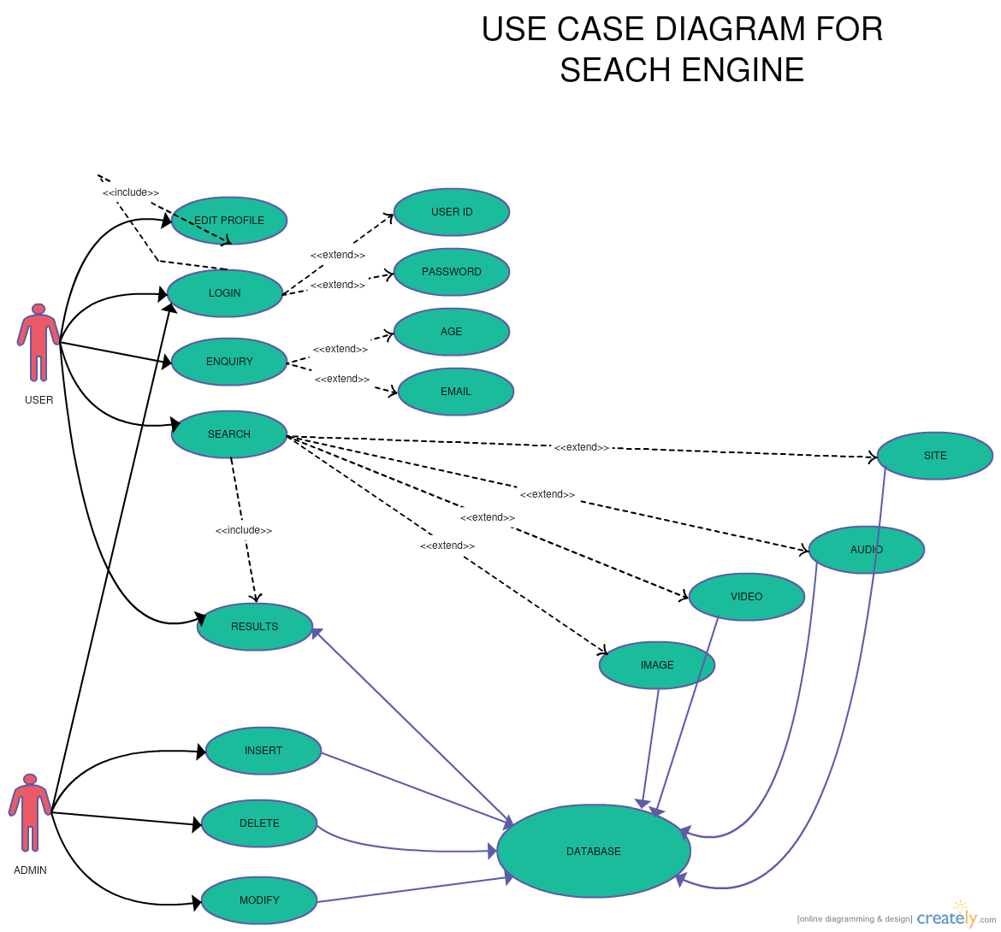
UC DIAGRAM FOR
SMART SEARCH for EDUCATION

System Feature 1
4.1.1 Description and Priority
We are implementing elastic search on the documents present on portal. Its difficult for the user to find a document and it takes a lot of time. Hence the unstructured search will make the work easy. It will work for all kind of file formats. If images is uploaded, it will be converted into text form and the search will take place.
4.1.2 Stimulus/Response Sequences
Stimulus: if user search for optical fiber in search box.
Response: the documents based on optical fiber will get listed in sorted manner.

4.1.3 Functional Requirements
The user must be able to enter valid text in search box.
TBD( others to be discuss)

REQUIREMENTS | DESCRIPTION
Suggest Doc | User can suggest documents
Edit Profile | Manage User Profile
Login | Metadata will be saved after login
User ID | User-ID of the User
Password | Password of the User
Follow Library | User can follow libraries
Search | User gives search keywords
History | Log of user search history
Upvote | User can upvote a document
Add to Library | User can add documents(books/notes) to personal  libraries
Result | Search results
Download Result : | Users can download documents
Insert | Admin can insert new documents
Delete | Admin can delete documents
Modify | Admin can modify documents
Image | Browse custom scanned images
View | View documents
Document | User can search within a document
Books | ––User can search for books
Database (UC20) | System Database

Other Nonfunctional Requirements

Performance Requirements
The search query is been searched in less time. The result will be generated within 5miliseconds. The result displayed will be sorted accordingly. The recognition of text from image will take approx 2 milliseconds which is efficient enough. The system should generate words found in any kind of file format i.e., pdf, word, etc.

Safety Requirements and Security Requirements
This requirement does not apply for our software as this is can’t cause a threat in no way.
All the operations are going to take place in a single system security is not an issue for this software. For the safer side follow given details:
Have the firewall enabled.
Differing hardware/software combination
Use auto update systems and browser like Windows Update, Linux: up2date, firefox,chrome etc.
Stay current with php, apache.

Software Quality Attributes
The following are the quality attributes for the software:
Portability: this can work on multiple platforms as it is depends on the browser so it’s portable. User Training: We assume that the users have already worked on such SSE. So user won’t need specific training for this.
Testability & Correctness: For correctness a software should be testable
Feature Set: Almost 100% matching what we have already.
Availability: It will be available to all education institutes, academician and large organisation as well as to open source community. It always pop up an error message if there is component failure.
Efficiency: Checks that the system provides the right tools to support all its features and even makes search optimized.

Business Rules
TBD ( not yet decided).

Other Requirements
All requirements are listed above till now.
Appendix A: Glossary
E-Learning : it means Electronic learning.
User: who use or going to use the product.
Web Application: application accessed over over a network by user.
Database: collection of data stored.

Appendix C: To Be Determined List
Hardware Interface
Functional Requirements
Business Rules

